New name and concept: GOOMEE

GOOMEE
“The world, your way!” Or “Let Life Find you”

First page with video concept
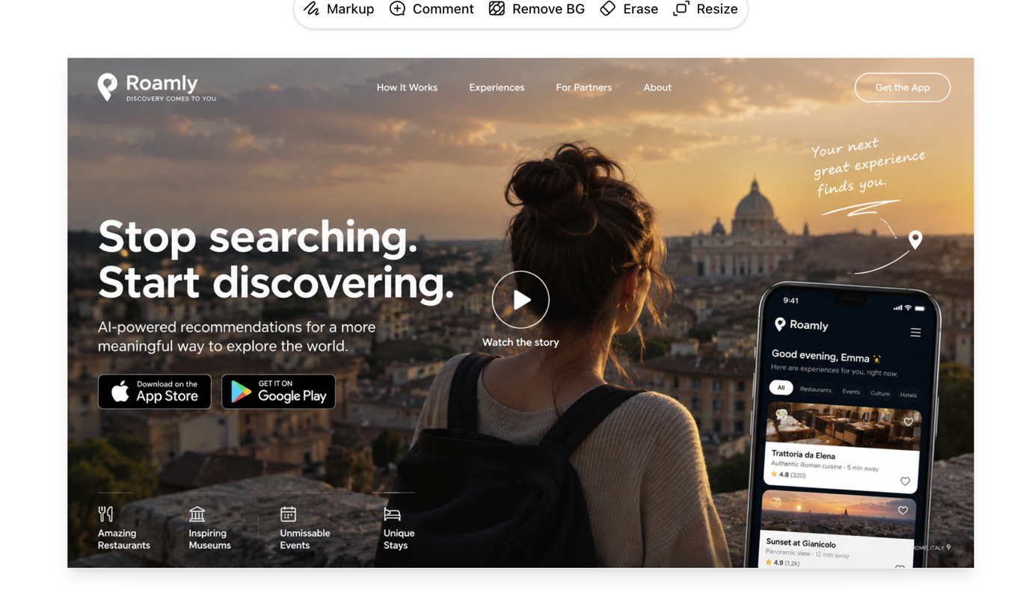
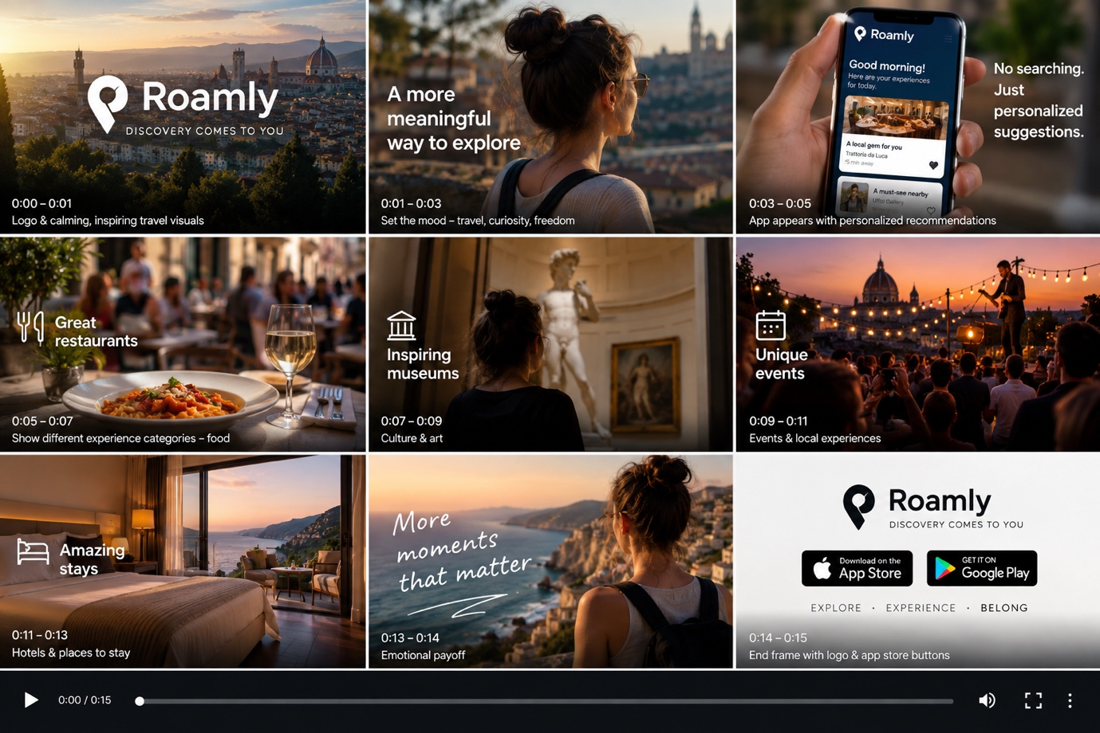

OR another video first page concept idea:
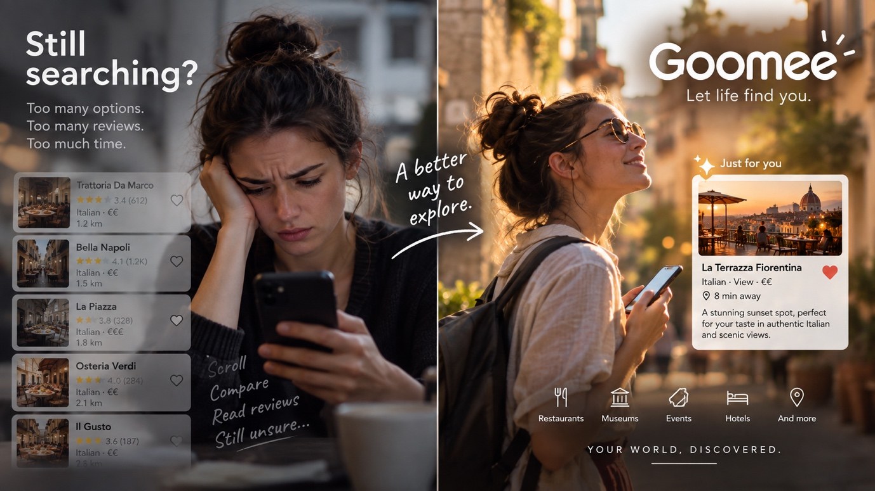

We can go with either choice. What is your thought? It should be a first landing page with a nice video.
The rest of the website could have this look. Let me know your thoughts. The first page with video should look like one of the abovechoices, not what is showing below; only first landing page.(see image lower)
